UID EX 8 240701595 vishaali R

AIM:
The aim is to create storyboards representing the user flow for a mobile E-commerce app using Balsamiq.

Procedure
- Tool Used: Balsamiq Wireframes (https://balsamiq.com)
- I created a new project and added mobile screens to simulate the user's shopping experience from start to finish.
- Each screen represents a key step in the product browsing and purchase process.
- UI components like buttons, text fields, dropdowns, images, and icons were selected from Balsamiq’s built-in library.
- All wireframes were designed to be simple, clean, and focused on user interaction and flow.

User Flow
- Homepage – Users can browse featured products, search for items, and navigate to different categories.
- Categories Screen – Displays various product categories such as Electronics, Fashion, Home, etc.
- Product List Screen – Shows a list of products within a selected category, with image, name, price, and “Add to Cart” button.
- Product Details Screen – Detailed view of a single product with description, images, price, and “Add to Cart” button.
- Checkout Screen – Shows the cart with total price, delivery address input, and a button to proceed.
- Payment Confirmation Screen – Displays payment options and a confirmation message after successful payment.

Homepage
  - Components:
    - Search bar
    - Banner/Carousel for offers
    - Navigation buttons to categories
    - Featured products with thumbnail, price, and "Add to Cart"

Purpose:
Starting point for exploring and engaging with the app’s product offerings.

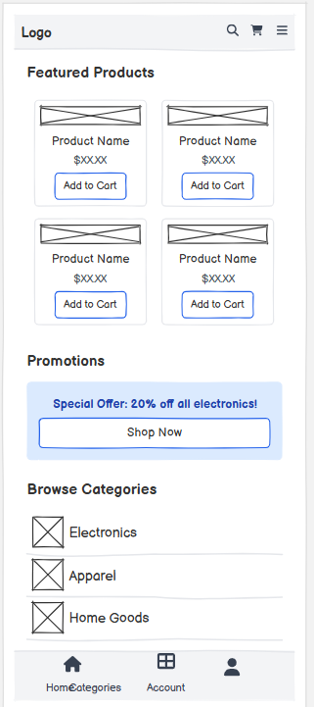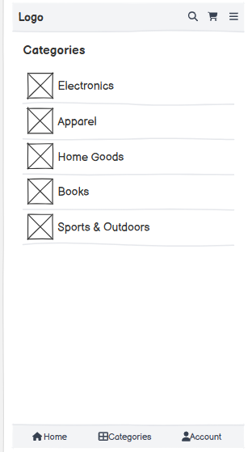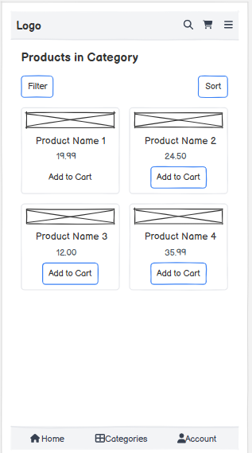

Categories Screen
  - Components:
    - Grid or list view of categories (e.g., Electronics, Fashion, Groceries)
    - Icons/images representing each category

Purpose:
Help users easily filter products based on interest.

Product List Screen
  - Components:
    - Scrollable list of products
    - Product image, name, price
    - “Add to Cart” button for each product

Purpose:
View and select products within a specific category.

Product Details Screen
  - Components:
    - Product image gallery
    - Title, price, ratings
    - Description and specifications
    - “Add to Cart” button

Purpose:
Provide full information about a product to aid in purchase decisions.

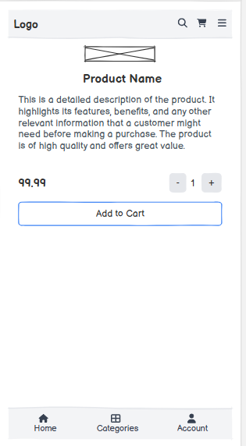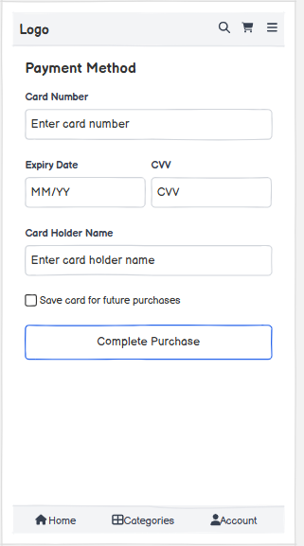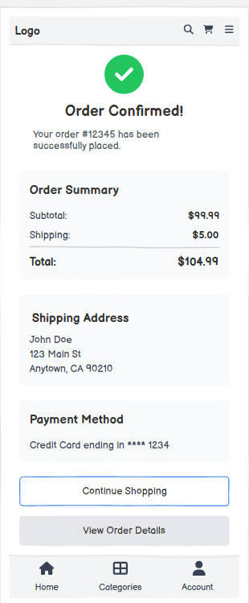

Checkout Screen
  - Components:
    - List of items in cart with price breakdown
    - Input fields for delivery address
    - “Proceed to Payment” button

Purpose:
Let users review their order and enter delivery details.

Payment Confirmation Screen
  - Components:
    - Radio buttons for payment methods (UPI, Credit Card, COD)
    - Order summary and total cost
    - “Pay Now” or “Confirm Payment” button
    - Confirmation message (e.g., “Payment Successful! Your order will arrive in 3-5 days.”)

Purpose:
Final confirmation step that assures the user the transaction is complete.

